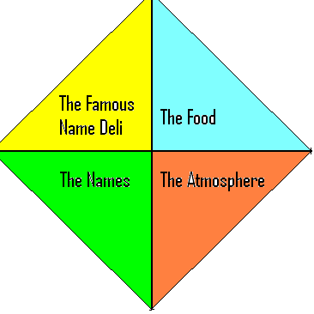
The Famous name Deli
2615 Naudain Street
Philadephia, Pa 19002
Dear Sirs:

Per the request of our auditors, we are submitting our payroll information for our employees. As we understand it, final pay designation that must go to IRS is the total of the salary and 8% of the sum of the costs of the meals where they are the waitperson. We’ve also submitted other personal information pertaining to sex and whether or not a city resident. Our company provides
Once you calculate the total salary, please calculate the following taxes:
FWT (Federal Wage tax): 15% of the total salary
Social security: 7.65% of the total salary
Phila wage tax: 3.78% if a resident, 3% if a non resident of full salary
Provide an insurance policy based on 3 times total salary or 100000 whichever is less. For women, the taxation on this insurance is $4 per thousand (.004), for Men it is $3 per thousand (.003).
The following are the full time waitpersons (or server staff), their salaries, and the sum of the checks for the meals that they served.
Last Name | First Name | Salary | Cost Of Meals | Sex | Resident Of Phila
Kelly | Grace | 14000 | 50000 | F | N
Grant | Cary | 10000 | 48000 | M | Y
Clinton | Hillary | 15000 | 54000 | F | N
Fleming | Ian | 15000 | 65000 | M | N
Hemingway | Ernest | 11000 | 80000 | M | Y
Roberts | Julia | 15000 | 40000 | F | Y
Simon | Carly | 15000 | 70000 | F | N
Castro | Fidel | 9000 | 36000 | M | N
Cassett | Mary | 10000 | 54000 | F | N
Nutter | Michael | 12000 | 60000 | M | Y
Christie | Chris | 5000 | 70000 | F | N
Lewinsky | Monica | 15000 | 85000 | F | Y
Tripp | Linda | 10000 | 50000 | F | Y
Roosevelt | Eleanor | 15000 | 45000 | F | Y
Wayne | John | 10000 | 36000 | M | Y
Paltrow | Gwyneth | 10000 | 54000 | F | N
Obama | Barak | 9000 | 35000 | M | N
Rendell | Ed | 15000 | 60000 | M | N
Stalin | Joseph | 12000 | 70000 | M | Y
Bond | James | 11000 | 65000 | M | N
Barry | John | 12000 | 55000 | M | Y
Washington | George | 8000 | 40000 | M | Y
Da Vinci | Leonardo | 12000 | 55000 | M | N
Rice | Susan | 10000 | 40000 | F | N
Truman | Bess | 9000 | 35000 | F | Y
Reddy | Helen | 12000 | 45000 | F | N
Christie | Agatha | 10000 | 40000 | F | N
Sills | Beverly | 9000 | 55000 | F | Y
Mitchell | Andrea | 13000 | 60000 | F | Y
Hilton | Paris | 12000 | 65000 | F | N

Click here to access the excel file that contains this information.

